**LAPORAN PRAKTIKUM INTERNET OF THINGS**

# **JOBSHEET-2**

# **LED**



**Dosen Pengampu :**

**Noprianto, S.Kom., M.Eng**

**Oleh:**

**Devi Puspitasari 1941720048**

**Fathin Naufaliya 2041723015**

**Fitri Mutiara Devi 1941720016**

**PROGRAM STUDI TEKNIK INFORMATIKA**

**JURUSAN TEKNOLOGI INFORMASI**

**POLITEKNIK NEGERI MALANG**

**MARET 2022**

**Praktikum**

### **Project 1: Running LED RGB**

kode program berikut pada Visual Studio Code

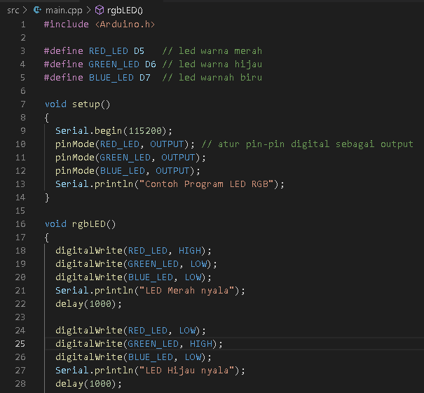

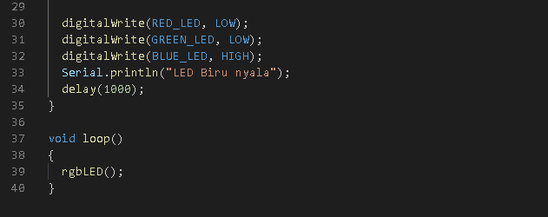

Link Video hasil project 1: <https://drive.google.com/file/d/1rQ6VuENfKEuwIxUCn4Nv7ajsuOLkjl2v/view?usp=sharing>

### **Project 2: SOS LED**

kode program berikut pada Visual Studio Code

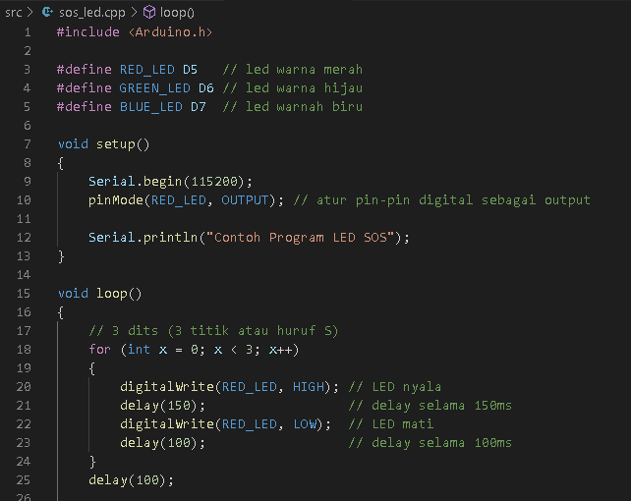

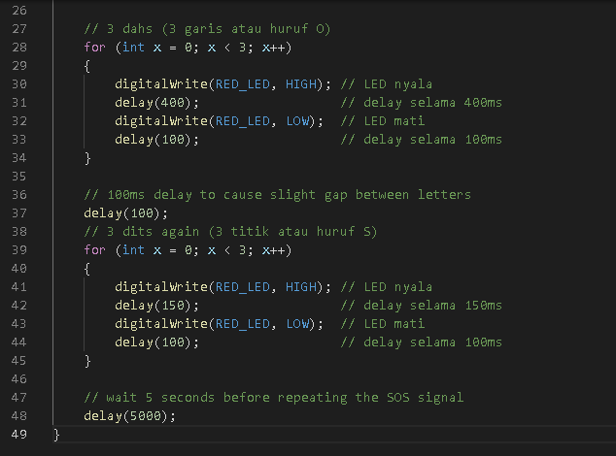

Link Video Hasil project 2 : <https://drive.google.com/file/d/1h01CBfzogXVVWpDynFgM5GT0D7l8oDJV/view?usp=sharing>

**TUGAS:**

Link video hasil : <https://drive.google.com/file/d/1w04bPTxhKA_Jb0NA4cIGWWO50DVVcDO0/view?usp=sharing>